Use relational operators to solve the following queries:

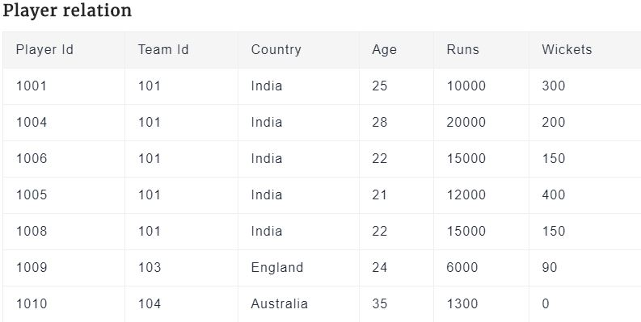

1.Select all the tuples for which runs are greater than or equal to 15000.



2.Select all the players whose runs are greater than or equal to 6000 and age is less than 25



3. List all the countries in Player relation.



2. 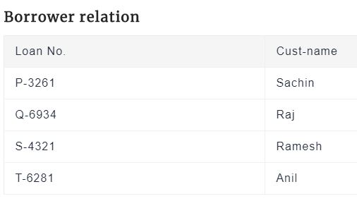

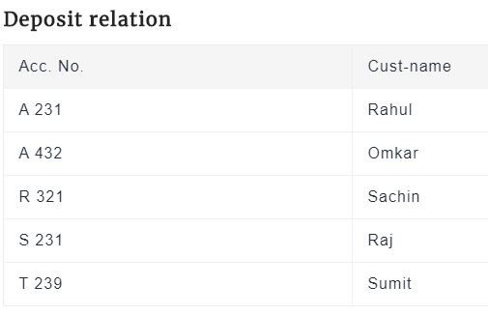

i)Find all the customers having an account but not the loan.



ii). Find all the customers having a loan but not the account.



iii)Rename Player relation to PlayerList



Consider the relational database given below. Give an expression in the relational algebra to express each of the following queries:

1. Find the names of all employees who work for “First Bank Corporation”.



1. Find the names and cities of residence of all employees who work for “First Bank Corporation”.



c. Find the names, street address, and cities of residence of all employees who work for “First Bank Corporation” and earn more than $10,000.





